Write all program in C using Structures

Question 1:
Build an Student record system that stores.
- Store student name, roll number, marks in 3 subjects
- Calculate percentage and grade based on marks
- Implement a grading system: A+(90-100), A(80-89), B+(70-79), B(60-69), C(50-59), F(<50)
- Add functionality to find students by grade
- Calculate class average and display students above/below average
Additional features:
- Input validation for marks (0-100)
- Search students by roll number or name
- Display student rank based on percentage
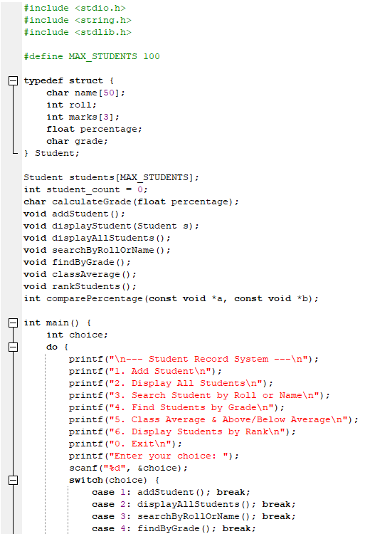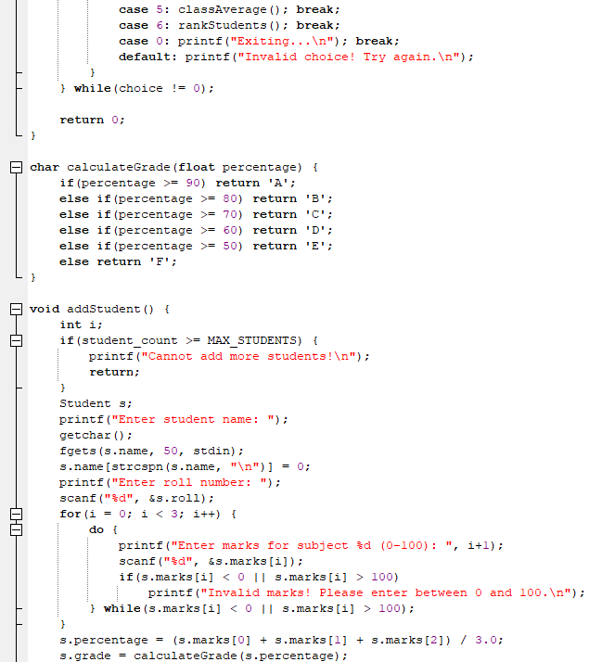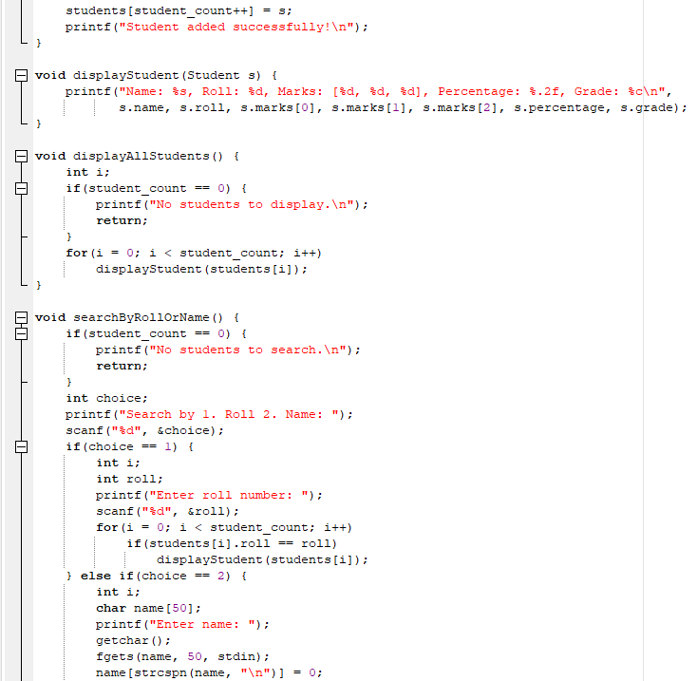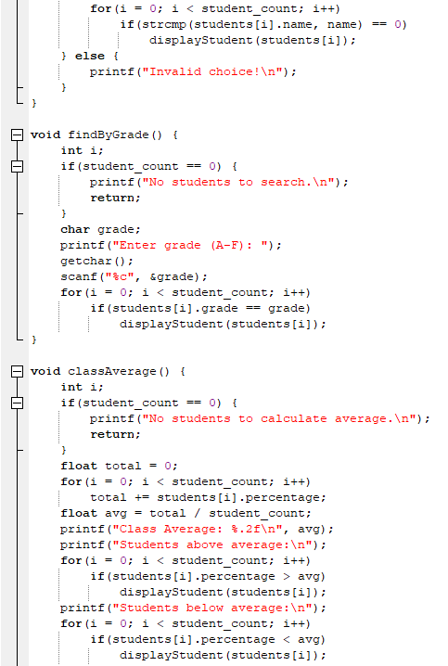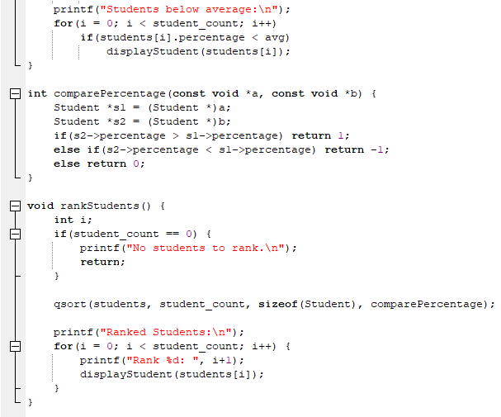
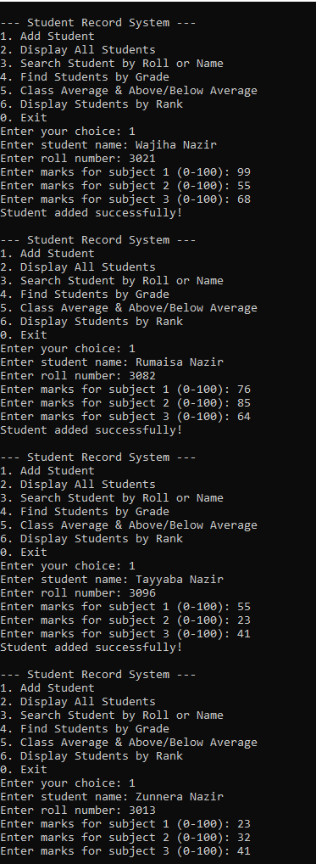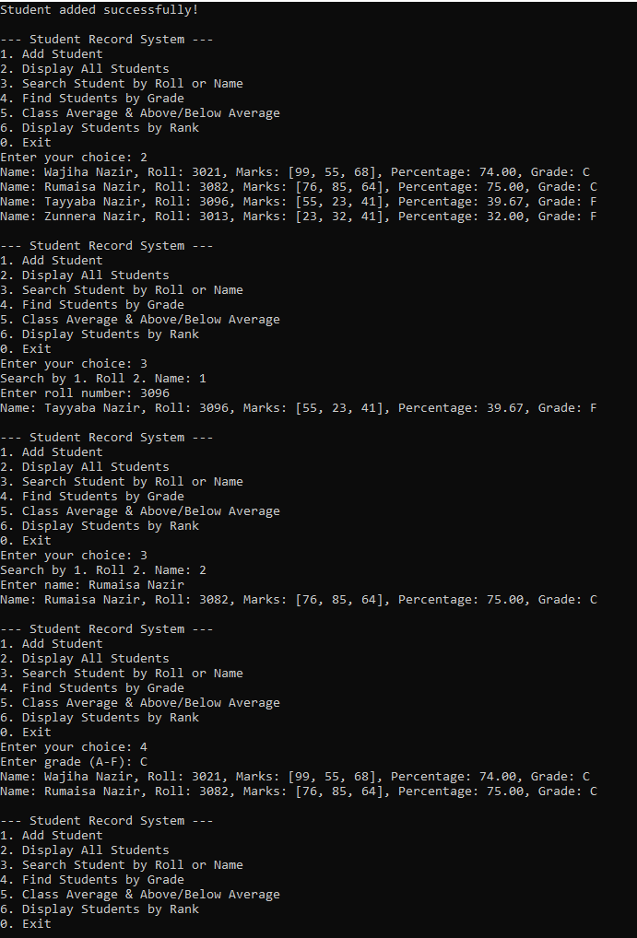
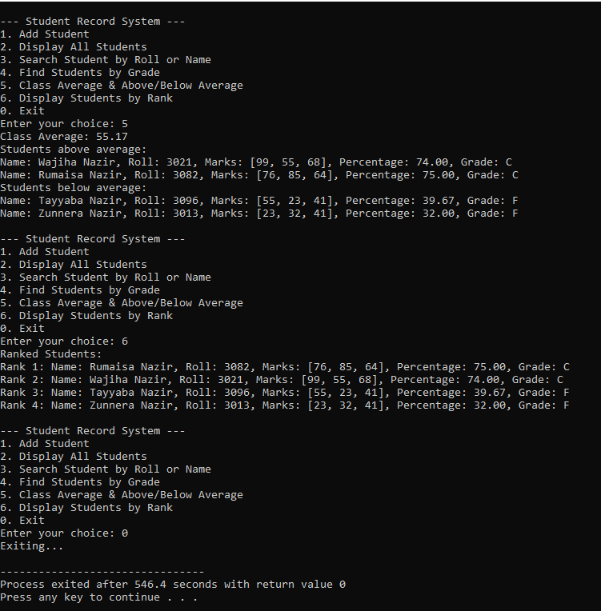
Question 2:
Build an Bank Account Management system that stores.
- Account types: Savings, Current, Fixed Deposit
- Minimum balance requirements: Savings($1000), Current($5000), Fixed Deposit($10000)
- Interest rates: Savings(4%), Fixed Deposit(7%), Current(0%)
- Transaction history with date and type (Deposit/Withdrawal)
- Account creation date and last transaction date
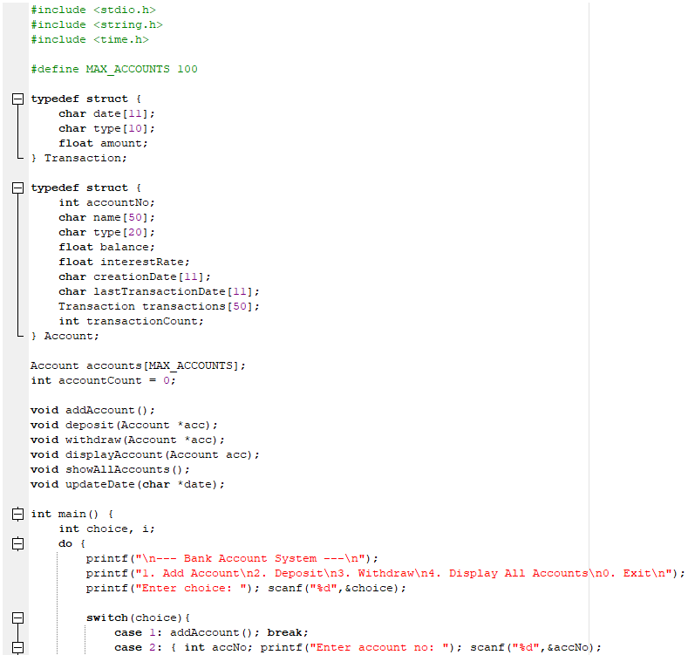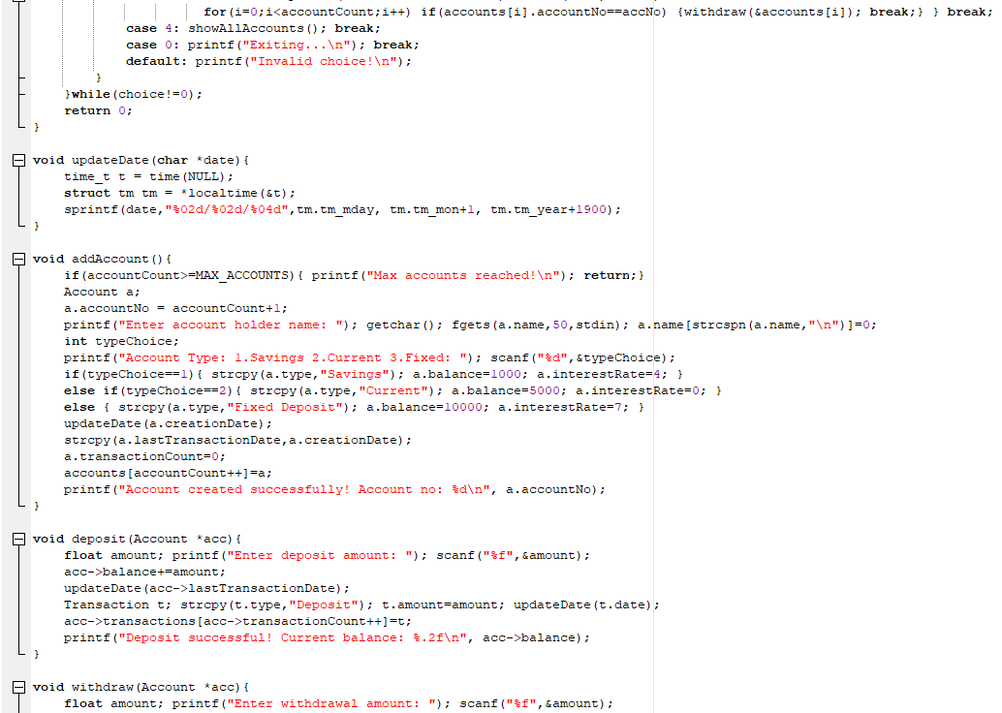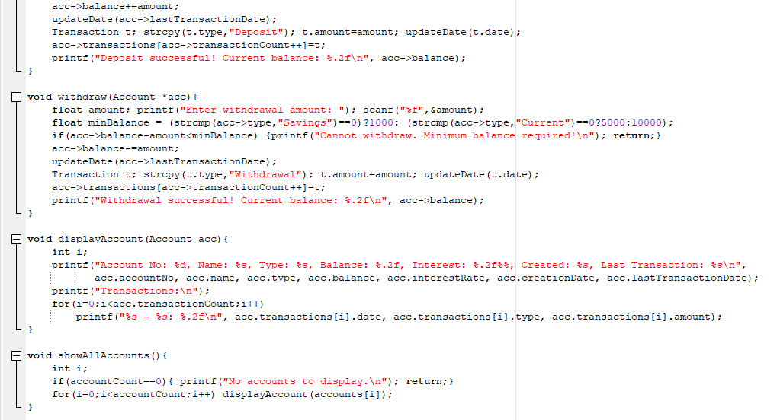
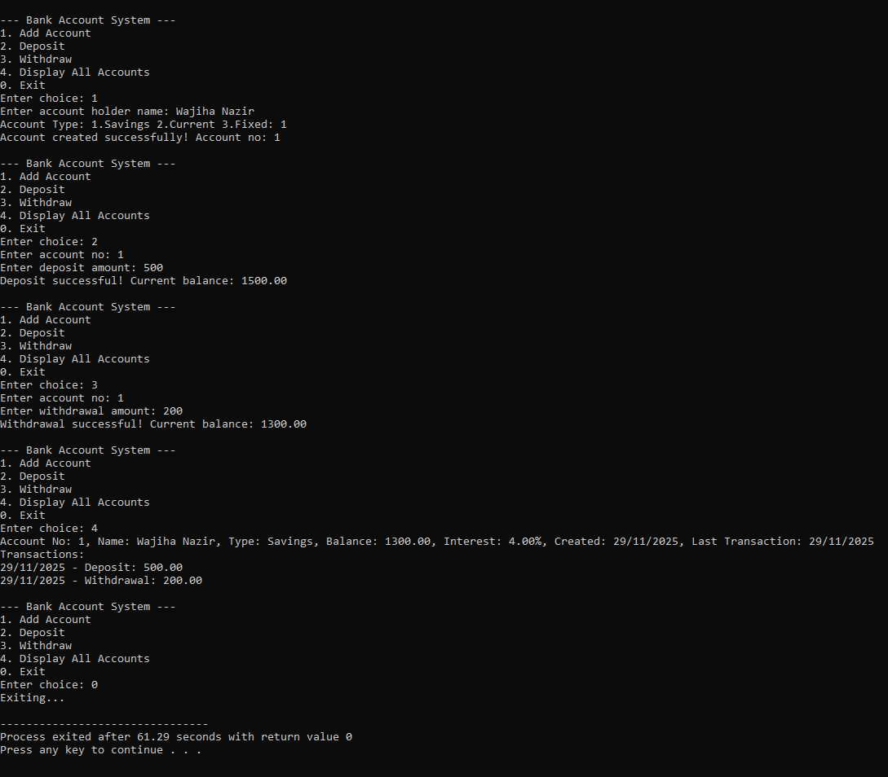
Question 3:
Build an employee record system that stores.
- Employee ID, name, department, designation, salary, date of joining, phone number, email
- Department categories: IT, HR, Finance, Marketing, Operations
- Designation hierarchy: Intern, Junior, Senior, Manager, Director
- Years of experience calculation based on joining date
Additional features:
- Department-wise salary statistics
- Annual appraisal with salary increment (5-15% based on performance)
- Search employees by department, designation, or experience
- Calculate and display employees eligible for promotion (>3 years in current role)
